Assignment 3

Name: G.Ashrita

Reg.No:21BCE8697

output:

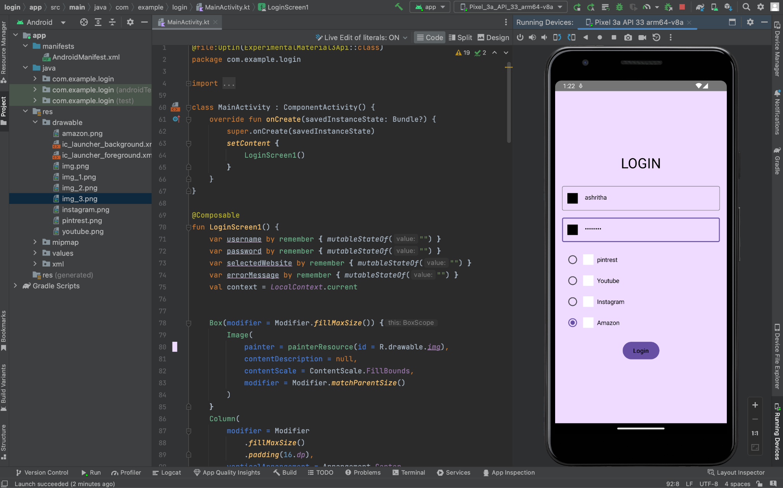

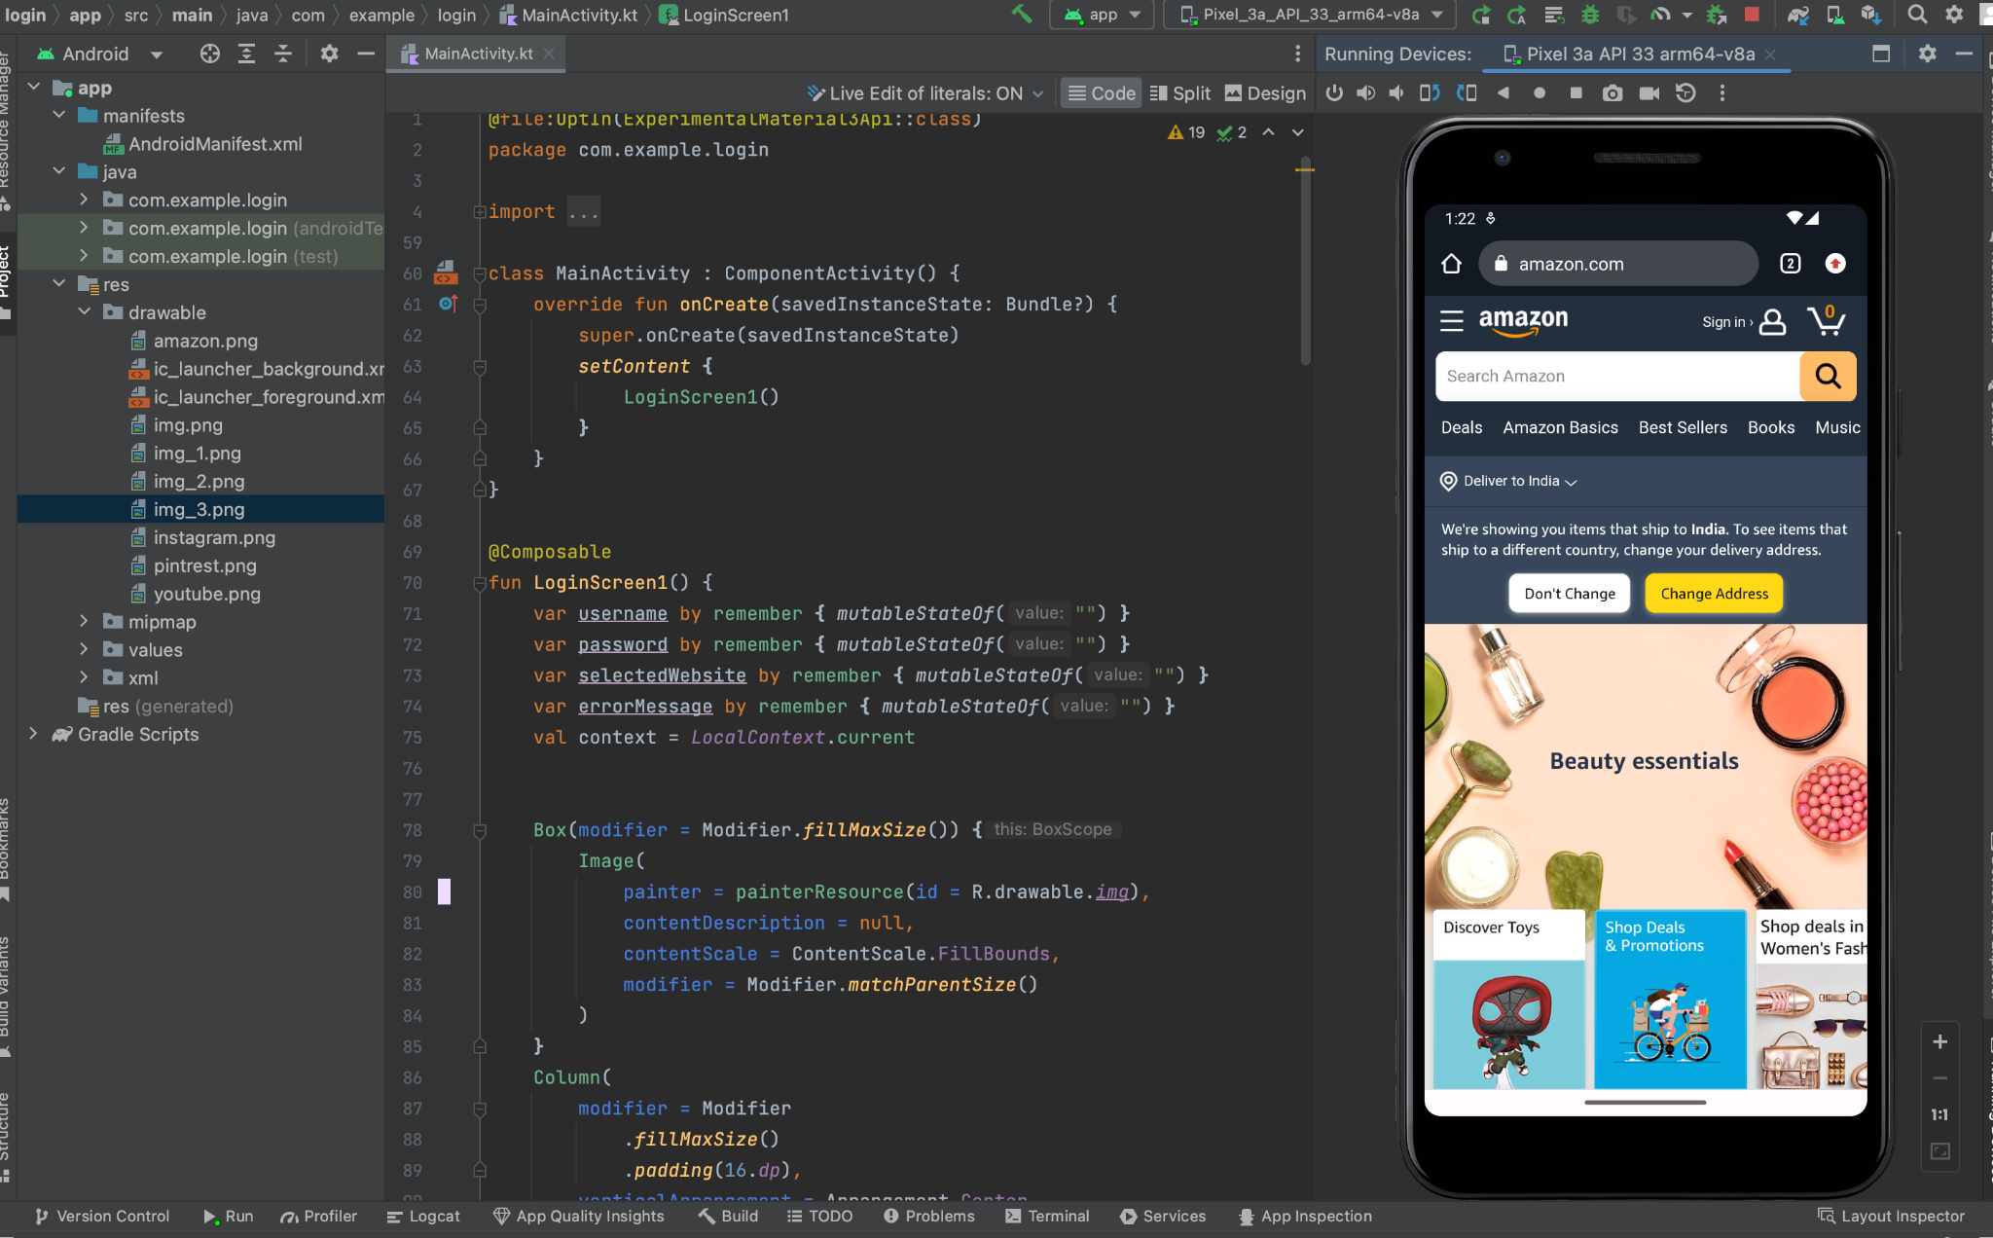

Drive link :

<https://drive.google.com/drive/folders/19CSyXqNNjpzCDwm8QGk2x_h4J8oR4Gmp?usp=sharing>